Water Quality IE Deployment Documentation

Intro
The following document aims to act as a support on how to implement each UseCase through
- Explaining the conceptual model : agree on what we are speaking about
- Once the conceptual model is understood : agree on which API we deploy to expose the corresponding dataset and how to configure it.

In this first approach all the use cases are well covered by the OGC/ISO Observations, measurements and samples standard (OMS : ISO 19156:2023).
The API of choice to expose Observations & Measurements (ISO 19156:2011) compliant data being OGC SensorThings API Part 1 : Sensing, work has been undertaken to identify missing elements and draft an OMS compliant version of SensorThings API Part 1 able to expose Water quality/quantity data.

This WQ IE SensorThings API has then been implemented in FROST implementation of SensorThings API specification.

In that context when writing SensorThings API we do refer to “SensorThings API Part 1 : Sensing”

Terms and definitions
The following terms and definitions have been taken from OGC Abstract Specification Topic 20: Observations, measurements and samples, OGC SensorThings API Part 1: Sensing Version 1.1 and extended with examples specific to the water quality domain

datastream
A Datastream groups a collection of Observations measuring the same ObservedProperty and produced by the same Sensor.
deployment
A Deployment shall be defined as information on the assignment of an Observer to a Host.
domain
well-defined set
domain feature
feature of a type defined within a particular application domain
ex situ
off-site
referring to the study, maintenance or conservation of a specimen or population away from its natural surroundings
EXAMPLE
feature
abstraction of real-world phenomena
feature type
class of features having common characteristics
feature-of-interest
subject of the observation
EXAMPLE

host
A Host shall be defined as a grouping of Observers for a specific reason. In many use cases, the Host is the environmental monitoring facility.The Host can be a platform that hosts a set of sensors. An alternative usage could pertain to a biodiversity survey campaign. In this scenario, the team performing the survey would be modelled as observers whereas the entire survey campaign can be represented as a Host. [OMS 3 8.7.2]
in situ
on-site
referring to the study, maintenance or conservation of a specimen or population without removing it from its natural surroundings
EXAMPLE typically referring to sensor-based water quality observations that are limited to a small number of observed properties including water temperature, dissolved oxygen, ammonium, nitrate, chloride, electrical conductivity, pH, ORP, total dissolved solids, total suspended solids
measure
<GML> value described using a numeric amount with a scale or using a scalar reference system
measurement
set of operations having the object of determining the value of a quantity
observable property
a quality (property, characteristic) of the feature-of-interest that can be observed [OMS 3 8.3.2]
observation
act carried out by an observer to determine the value of an observable property of an object (feature-of-interest) by using a procedure, with the value provided as the result
observation collection
a collection of similar Observations
observation result
estimate of the value of a property determined through a known observation procedure
EXAMPLE dissolved oxygen concentration measured through an optical dissolved oxygen sensor
observer
identifiable entity that can generate observations pertaining to an observable property by implementing a procedure
EXAMPLE a water quality sensor measuring dissolved oxygen or a laboratory technician applying a laboratory analytical method such as 4500-O C. Azide Modification to determine dissolved oxygen concentration from a water sample

observing capability

observing procedure
the description of steps performed in order to determine the value of an observableProperty by an Observer. [OMS 3 8.5.2]
procedure
specified way to carry out an activity or a process
preparation procedure
the description of preparation steps performed on a Sample
preparation step
property
facet or attribute of an object referenced by a name
proximate feature-of-interest
entity that is directly of interest in the act of observing
range
<coverage> set of feature attribute values associated by a function, the coverage, with the elements of the domain of a coverage
sample
object that is representative of a concept, real-world object or phenomenon
EXAMPLE Water sample taken from a waterbody to determine the value of an observable property using a laboratory analysis method

sample collection
a collection of Samples
sampler
device or entity (including humans) that is used by, or implements, a sampling procedure to create or transform one or more sample(s)
EXAMPLE Automatic water sampler for discrete grab samples
sampling
an object that is representative of a concept, real-world object or phenomenon [OMS 3 11.2.2]
EXAMPLE 6 Extracting a sample from a defined environmental monitoring station.
sampling procedure
the description of steps performed by a Sampler in order to extract a Sample from its sampledFeature in the frame of a Sampling [OMS 3 11.7.2]
sensor
element of a measuring system that is directly affected by a phenomenon, body, or substance carrying a quantity to be measured
EXAMPLE dissolved oxygen optical sensor

thing
an object of the physical world (physical things) or the information world (virtual things) that is capable of being identified and integrated into communication networks [ITU-T Y.2060]
ultimate feature-of-interest
entity that is ultimately of interest in the act of observing
EXAMPLE
unit of measure
reference quantity chosen from a unit equivalence group
EXAMPLE milligram per litre (mg/L)
value
element of a type domain

Quick start

Underlying data model
Based on O&M/OMS, extending STA implementation of O&M…
https://umltool.ogc.org/index.php?m=7&o=BDD2204B-5E02-44b5-8F54-10A230C2491F

FROST implementation
To test the data model developed in the WaterQuality IE, it was implemented as a data model plugin for the FROST SensorThings API implementation.

FROST Sandbox
You can try this all right now, if you want! But you can also read the rest of the document first, and come back here later.

If you don’t feel like installing anything yourself, you can try the demo service.

The data models introduced in this document, extending the core SensorThings data model, are provided as a plugin for the FROST-Server implementation of the SensorThings API. The extension is available from the GitHub Project page of the extension, and as a Docker image.

Docker Deployment
The easiest way to deploy FROST with the data model extension is using the Docker image. An example docker-compose file is available for this.

Annex ‘SensorThings API : API reference documentation’ provides guidance on
- Order of operation to feed a SensorThings API endpoint
- Usual GET, POST operation to use when interacting with a SensorThings API endpoint

Then following chapters will guide through the specificities of each Use Case with regards FROST deployment and feeding.

UseCase Overview
The following Use cases are further described in this document
- SurfaceWater In-situ Quantity refers to observation data acquired on site regarding river flow, river height
- SurfaceWater In-situ Quality refers to observation data acquired on site regarding observable properties such as temperature, conductivity
- SurfaceWater Ex-situ Quality refers to observation data acquired on samples taken ex-situ for further analysis (to a lab). Properties observed could be about temperature, conductivity but also about various chemicals found in water

- GroundWater In-situ Quantity refers to observation data acquired on site regarding groundwater level
- GroundWater In-situ Quality refers to observation data acquired on site regarding observable properties such as temperature, conductivity
- GroundWater Ex-situ Quality refers to observation data acquired on samples taken ex-situ for further analysis (to a lab). Properties observed could be about temperature, conductivity but also about various chemicals found in water

Surface Water

Surface Water In-situ Quantity

UseCase Requirements
- We install sensors in a fixed location that measure the height of the water (e.g. stage). These are deployed at ideal locations within the stream to capture flow over a wide range of conditions (baseflow, low flow, flood, etc). We use the stage data to compute stream discharge based on a manually acquired relationship between stage and discharge (e.g. rating curve).
- Key metadata for in situ water quantity data: To be able to use in situ water quantity data, users must know various information about the sensor itself, including location (latitude, longitude, altitude), the type of sensor (this relates to measurement accuracy and reliability), and whether there are other measured properties associated with that sensor. For the measurement observations, users need to know when the measurement occurred (date/time/time zone), sampling procedures, and measurement units.

Modelling view
The following image describes the Object diagram demonstrating the use of Observations, measurements and samples for Surface Water In-situ Quantity use case. The live version is available online here: https://umltool.ogc.org/index.php?m=7&o=FD08F420-7A73-4242-B105-6C3BB99A046A.

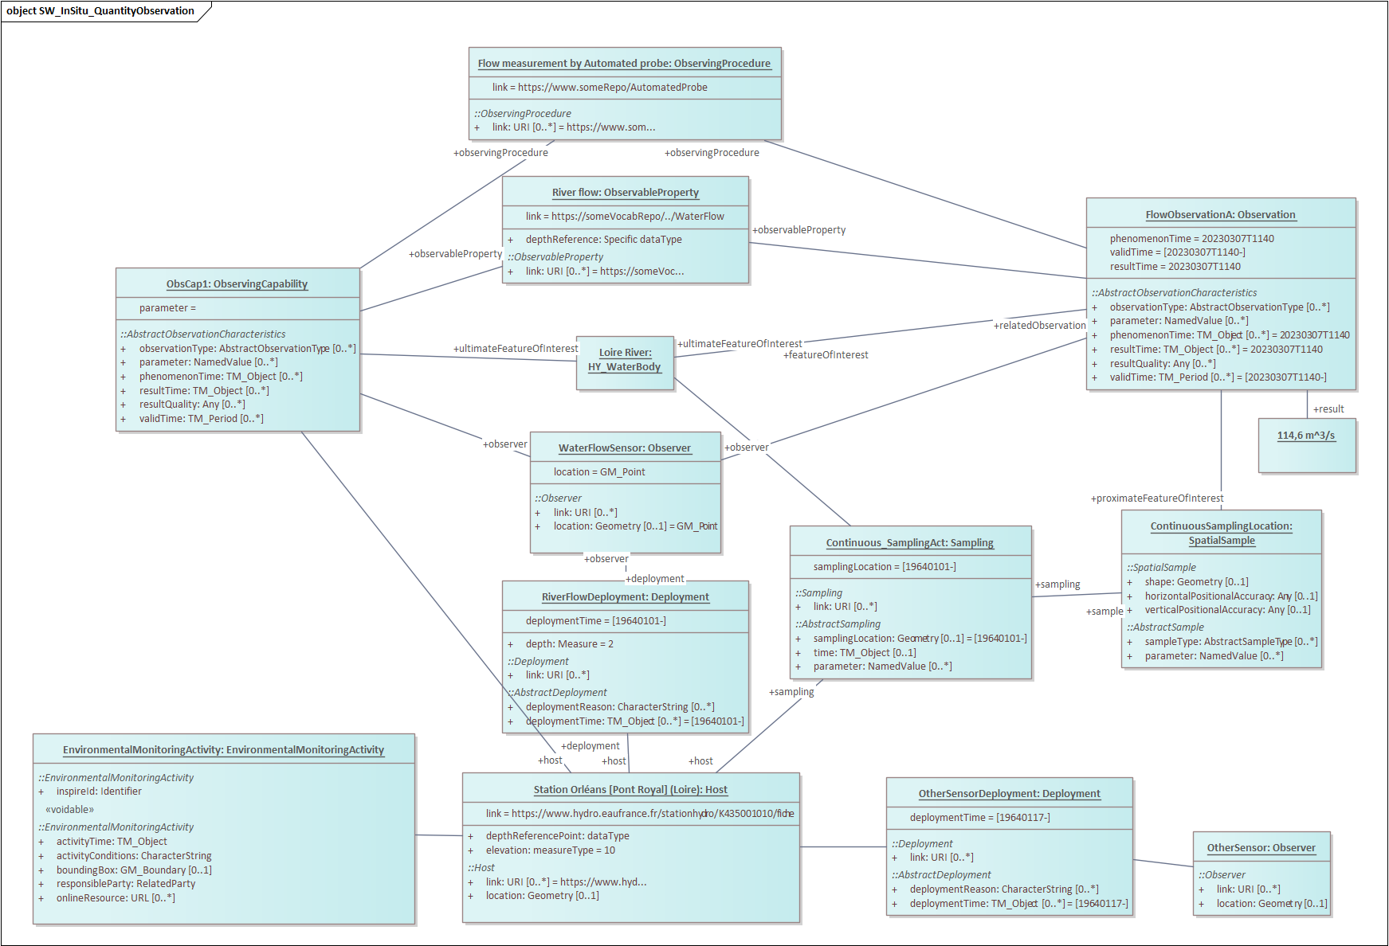
Applying OMS to this UseCase data objects are organized as follows
- The “Host” is what we usually call a station on which Sensors (called “Observer”) are deployed (“Deployment”).
- A “Host” lists what he observes through “ObservingCapability” that describes each property (“ObservableProperty”) / observation method (“ObservingProcedure”) couples along with the real world object being monitored : River, Catchment, etc.. (“ultimateFeatureOfInterest”)
- A Continuous Sampling act (“Sampling”) is created for a host along with a sampling location (“SpatialSample)
- Then each “Observation” / “ObservationCollection” is added accordingly
Thus respecting the “observableProperty”, “observingProcedure” and “ultimateFeatureOfInterest” that are declared at the “ObservingCapability” level.

SurfaceWater In-Situ Quality

UseCase Requirements
Surface water in-situ quality refers to observation data acquired on site regarding observable properties such as temperature, conductivity, pH, dissolved oxygen, nitrogen species (nitrate, nitrite, ammonium) and phosphate. Measurements are conducted by deploying different sensors either stationary at various depths on buoys or other structures in rivers or lakes, or temporarily during sampling activities. Most existing sensors use optical (colorimetric, fluorescence), electrochemical (potentiometric, amperometric) and electric sensing methods These sensors require periodic maintenance such as calibration and cleaning.
To be able to use in situ water quality data, users must know various information about the sensor itself, including location (latitude, longitude, altitude), the type of sensor (this relates to measurement accuracy and reliability), and whether there are other measured properties associated with that sensor.

Modelling View

The following image describes the Object diagram demonstrating the use of Observations, measurements and samples for Surface Water In-situ Quality use case. The live version is available online here:
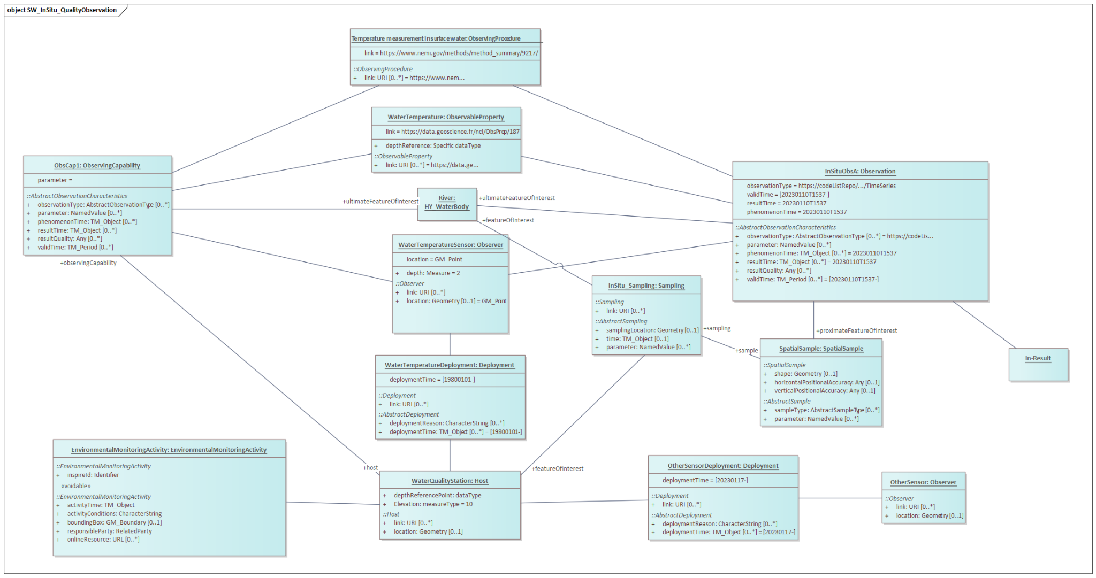

SurfaceWater Ex-Situ Quality

UseCase Requirements
Surface water ex-situ quality refers to observation data acquired on samples collected at a site and taken to a laboratory for further analysis. The range of laboratory measurements is vast and includes measurements of nutrients in various speciation states, trace metals, contaminants, pharmaceuticals, DNA, stable isotopes, etc. In-situ measurements such as temperature and conductivity are often taken on the sample at the site and then the sample is prepared for storage and transport to the laboratory. Sampling occurs following specific collection and sample preparation protocols to ensure the samples are suitable for the target laboratory analyses.
To be able to use ex-situ water quality data, for the measurement observations, users need to know when the measurement occurred (date/time/time zone), sampling procedures including location (latitude, longitude, altitude), measurement units, and sometimes which chemical species are being measured.

Modelling View
Object diagrams in EA
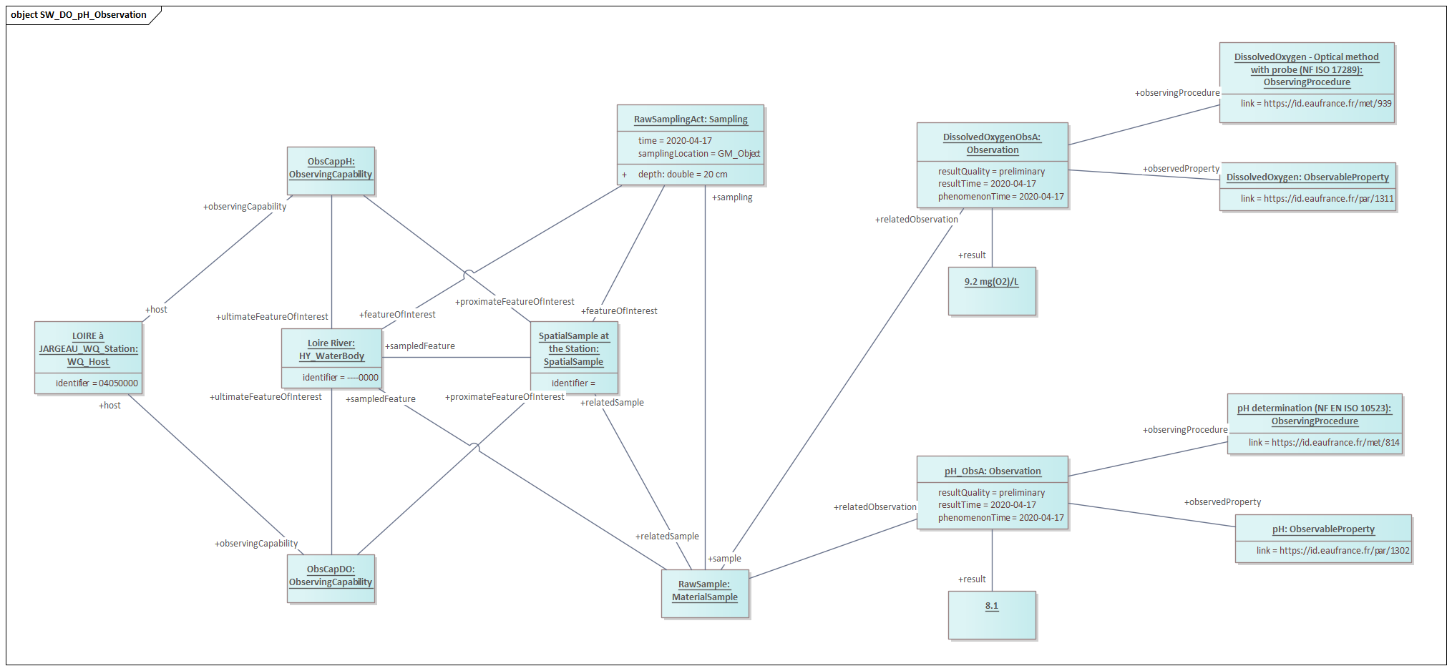

GroundWater

GroundWater In-Situ Quantity

UseCase requirements
GroundWater In-situ Quantity refers to observation data acquired on site regarding groundwater levels or groundwater elevation. Measurements are conducted by deploying different measuring instruments, such as transducers or acoustic beam devices, in or on a groundwater well. Groundwater wells may strictly be used for purposes of observation, or may be used for other purposes, such as domestic production. Sensors help to determine the depth to water below a measuring point in the well. Groundwater sensors do require periodic maintenance such as calibration.
To be able to use in-situ groundwater quantity data, data users must know information about the well itself, including location (latitude, longitude, altitude, and datum), the type of sensor, and if the measurement is being reported relative to land surface or as an elevation relative to a datum. For the measurement observations, users need to know when the measurement occurred (date/time/time zone), sampling procedures, measurement units, and information about the hydrogeologic context (aquifer properties) that the well and measurement represent.

Modelling View

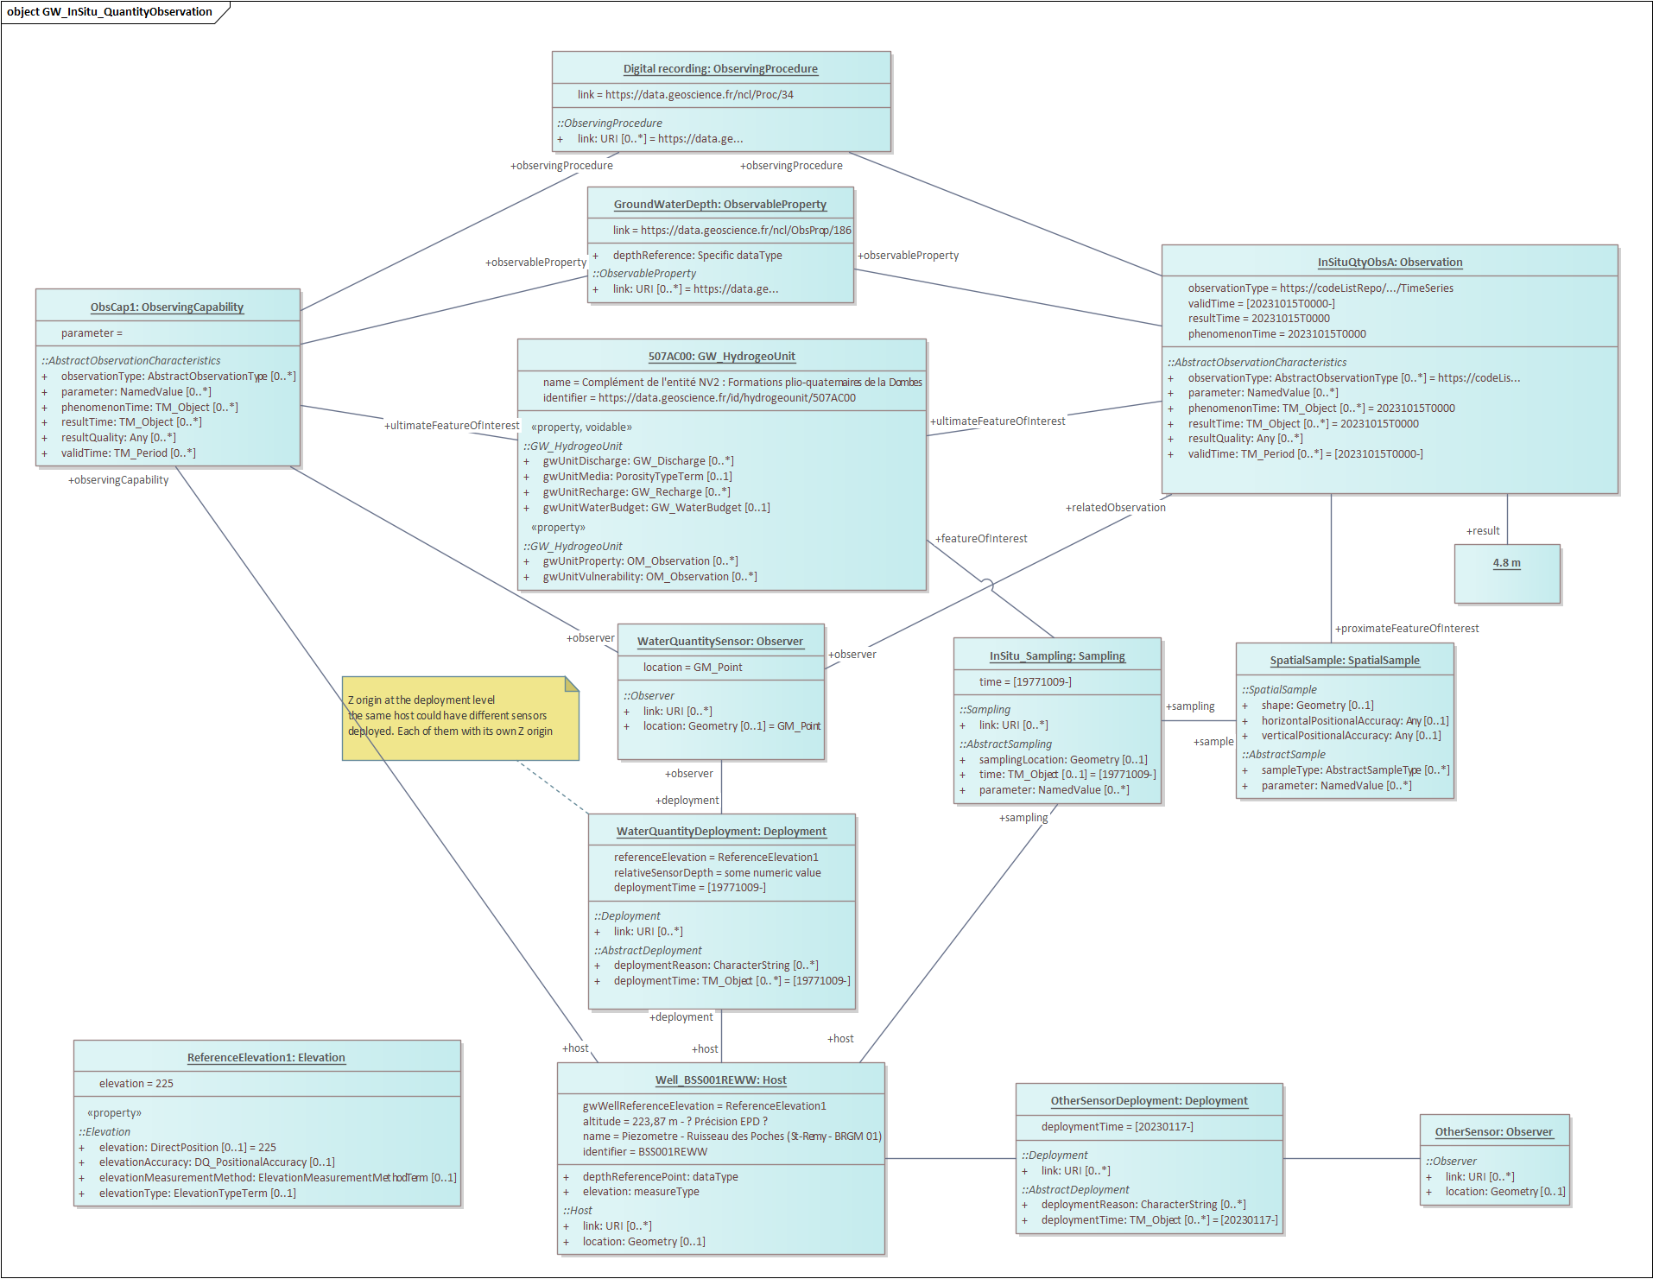

GroundWater In-Situ Quality

UseCase Requirements
GroundWater In-situ Quantity refers to observation data acquired on site regarding observable groundwater properties such as temperature, conductivity, pH, dissolved oxygen, nitrogen species (nitrate, nitrite, ammonium) and phosphate. Measurements are conducted by deploying different sensors stationary at various depths. Most existing sensors use optical (colorimetric, fluorescence), electrochemical (potentiometric, amperometric) and electric sensing methods These sensors require periodic maintenance such as calibration and cleaning.
To be able to use in-situ groundwater quality data, users must know various information about the sensor itself, including location (latitude, longitude, altitude), the type of sensor (this relates to measurement accuracy and reliability), and whether there are other measured properties associated with that sensor. For the measurement observations, users need to know when the measurement occurred (date/time/time zone), sampling procedures, measurement units, sometimes which chemical species are being measured, and information about the hydrogeologic context (aquifer properties) that the well and measurement represent..

Modelling View
Object diagrams in EA

GroundWater Ex-Situ Quality

UseCase Requirements
GroundWater Ex-situ Quality refers to observation data acquired from samples collected at a well. Samples collected at a site are sent to a laboratory for further analysis. The range of laboratory measurements is vast and includes measurements of nutrients in various speciation states, trace metals, contaminants, pharmaceuticals, DNA, stable isotopes, etc. In-situ measurements such as temperature and conductivity are often taken on the sample at the site and then the sample is prepared for storage and transport to the laboratory. Sampling occurs following specific collection and sample preparation protocols to ensure the samples are suitable for the target laboratory analyses and that the groundwater sample is representative of the aquifer, not a holding tank or other groundwater storage devices.
To be able to use ex-situ groundwater quality data, users must know various information about the monitoring location, such as latitude, longitude, altitude, and the aquifer that the well is representing. For the measurement observations, users need to know when the measurement occurred (date/time/time zone), sampling procedures including location (latitude, longitude, altitude, vertical component of the sample), measurement units, laboratory methodology, information about sample handling (such as filtering), which chemical species is being measured and its speciation, and sample fraction.

Modelling View
Object diagrams in EA

Model Implementation

Model Overview
The implementation being based on Sensor Things API 1.1 with additional extensions from the IE.
A complete introduction of the standard is available in Annex II.
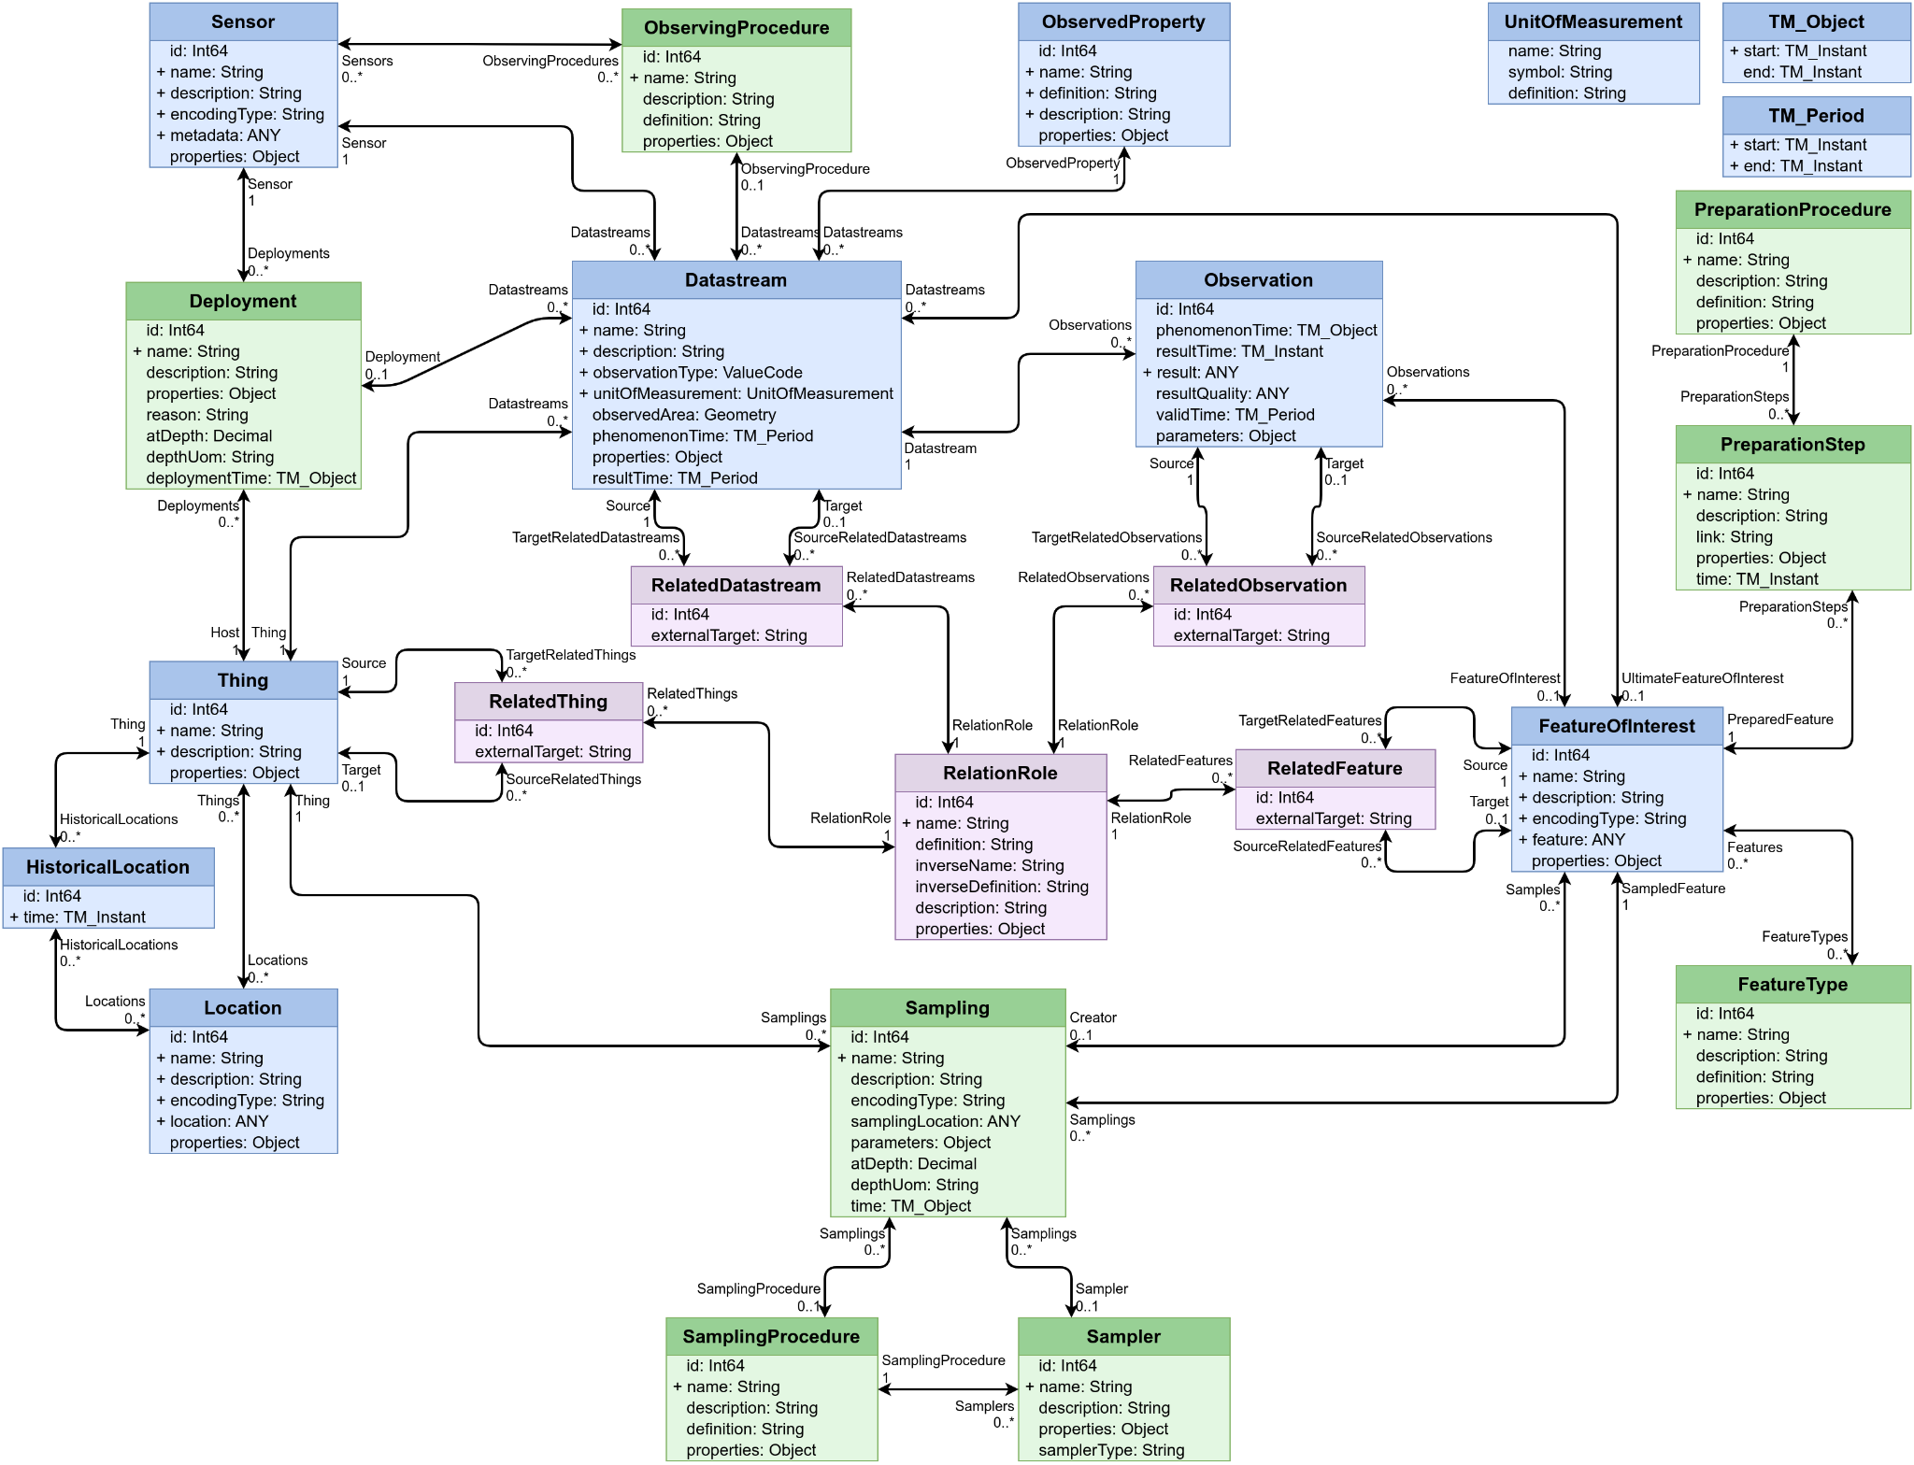

Surface Water

Surface Water In-situ Quantity

Physical (implementation) View
SensorThings API 2.0 draft WQ IE : reduced to the scope of the UseCase (less content VS labels)
Not necessary classes for that Use Case have been greyed out in the next diagram.

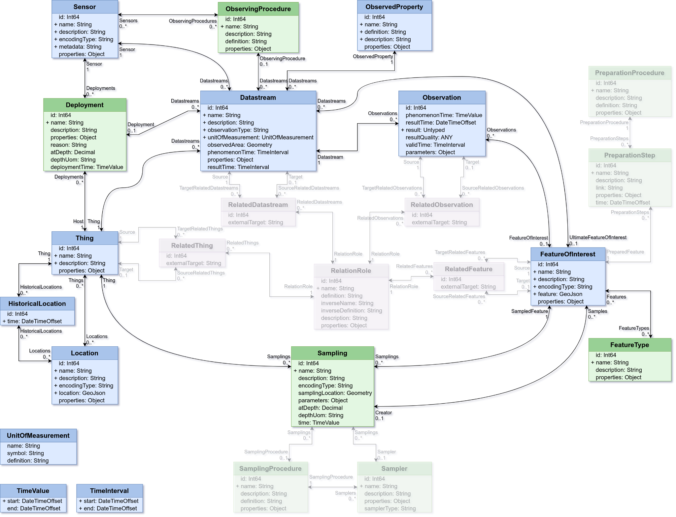

To simplify reading those classes have been removed from the subsequent one.

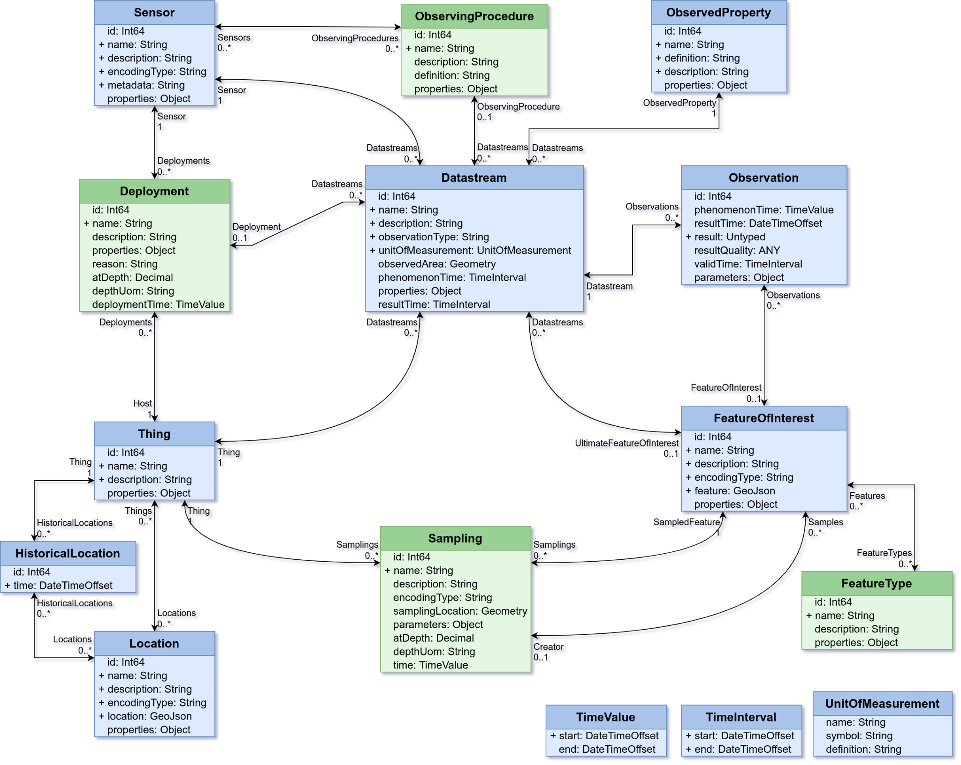

SurfaceWater In-Situ Quality

Physical (implementation) View
SensorThings API 2.0 draft WQ IE : reduced to the scope of the UseCase (less content VS labels)

SurfaceWater Ex-Situ Quality

Physical (implementation) View
SensorThings API 2.0 draft WQ IE : reduced to the scope of the UseCase (less content VS labels)’

GroundWater

GroundWater In-Situ Quantity

Physical (implementation) View
SensorThings API 2.0 draft WQ IE : reduced to the scope of the UseCase (less content VS labels)

GroundWater In-Situ Quality

Physical (implementation) View
SensorThings API 2.0 draft WQ IE : reduced to the scope of the UseCase (less content VS labels)

GroundWater Ex-Situ Quality

Physical (implementation) View
SensorThings API 2.0 draft WQ IE : reduced to the scope of the UseCase (less content VS labels)

How to map your system to the WQ IE approach
Various mappings have been made during the Water Quality IE. They are available in the Github of the IE : https://github.com/opengeospatial/WaterQualityIE/tree/master. People can take inspiration from the available mappings

Annex I - SensorThings API 1.1 complete version

Many classes have the fields id, name, description, definition and properties. The semantics of these fields are always the same and are thus not repeated for every class:
- @iot.id: The primary key of the Entity. It must be unique among Entities of the given Entity Type. Can be of type numeric, String or UUID.
- name: The name of the Entity, not necessarily human readable.
- description: A human readable description of the Entity.
- definition: A global URI of the Entity. Usually points to an entry in a codelist or ontology.
- properties: A free JSON Object for any additional data.

Thing
Some real-world thing, in this context usually the thing where the sensor is located. This could be a monitoring station or just the room where the sensor has been mounted. A Thing has the common fields @iot.id, name, description and properties. Each Thing can have the following relations:
- Locations: A Thing has one physical location. This location can be described in different ways. Therefore the Locations relation of the Thing can link to multiple Locations that are all different descriptions of this physical location.
- HistoricalLocations: Things that move are linked to the previous Location that those Things have been through the HistoricalLocations relation.
- Datastreams: The Datastreams (Observation collections) relevant for this Thing (monitoring station).

Location
Location of the Thing. The Location is provided separately from the Thing as a Thing can move to a different Location. A Location has the common fields @iot.id, name, description and properties. Besides these, a Location also has the following fields:
- encodingType: The way the location field is encoded. Generally this will be application/geo+json.
- location: The “geometry” of the location, encoded according to the given encodingType. Usually this will be a GeoJSON object.
Each Location can have the following relations:
- Things: The list of Things (monitoring stations) currently located at this Location.
- HistoricalLocations: The historic list of when Things were located at this Location. Only relevant when Things move.

HistoricalLocation
Links a Location to a Thing, with the time at which the Thing was at this Location. Besides the common field @iot.id, a HistoricalLocation has one field:
time: The time at which the Thing arrived at the linked Location.
Each HistoricalLocation has the following relations:
- Thing (mandatory): The Thing for which this HistoricalLocation describes the time and Location.
- Locations: The descriptions of the Location of the Thing at a certain historical time.

Datastream
A Datastream links together a Thing with a Sensor that is measuring an ObservedProperty to provide an entry point for a time series. All Observations created by the Sensor pertaining to the ObservedProperty are linked to this Datastream. Besides the common fields @iot.id, name, description and properties, a Datastream has the following fields:
- observationType: The O&M Valuecode for the type of Observation.
- unitOfMeasurement: The unit of measurement. It has three sub-fields: name, code and definition.
- observedArea: The area, or bounding polygon in which all Observations are made. If all Observations are made at the same point-location, the observedArea is also a point.
- phenomenonTime: The time interval spanning all phenomenonTimes of all Observations in the Datastream.
- resultTime: The time interval spanning all resultTimes of all Observations in the Datastream.
Each Datastream has the following relations:
- Thing (mandatory): This Thing is the monitoring station that the Datastream contains Observations for.
- Sensor (mandatory): This is the Sensor that created the Observations contained in the Datastream.
- ObservedProperty (mandatory): What the Observations in this Datastream measure.
- Observations: The list of Observations in the Datastream.

Sensor
A description of a sensor that provides values, including information on the measurement method. While formally designed for sensors in the IoT context, the Sensor could also be a human observer. Besides the common fields @iot.id, name, description and properties, a Sensor has the following fields:
- encodingType: The mime-type of the metadata field.
- metadata: The metadata of the sensor.
Each Sensor has the following relations:
- Datastreams: The list of Datastreams that this sensor sends Observations to.

ObservedProperty
The ObservedProperties describe what is being measured by a Sensor at a specific Location. Besides the common fields @iot.id, name, description and properties, an ObservedProperty has the following field:
- definition: The URI that identifies the ObservedProperty.
Each ObservedProperty has the following relations:
- Datastreams: The list of Datastreams that have Observations described by this ObservedProperty.

Observation
A single measurement value. Information on what ObservedProperty was measured with which type of Sensor is provided by the Datastream to which this Observation is linked; the object on which the measurement was performed is provided by the FeatureOfInterest of this Observation. Besides the common field @iot.id, an Observation has the following properties:
- result: The value of the ObservedProperty of the FeatureOfInterest at the time the Observation was made.
- phenomenonTime: The time at which the ObservedProperty had the given value. This can be a time instant or a time interval.
- resultTime: The time at which the value of the Observation became available.
- validTime: The time interval during which the result is deemed usable.
- resultQuality: The quality of the result.
- parameters: Any parameters that were of importance for determining the result.
Each Observation has the following relations:
- Datastream (mandatory): The Datastream that this Observation is contained in.
- FeatureOfInterest (mandatory): The FeatureOfInterest that the result of this Observation relates to.

FeatureOfInterest
the FeatureOfInterest is the object on which the measurement was performed. A Location has the common fields @iot.id, name, description and properties. Besides these, a FeatureOfInterest has the following fields:
- encodingType: The way the feature field is encoded. Generally this will be application/geo+json.
- feature: The “geometry” of the FeatureOfInterest, encoded according to the given encodingType. Usually this will be a GeoJSON object.
Each FeatureOfInterest has the following relations:
- Observations: The list of Observations that have results that describe this Feature.
In the context of the WQ IE and STA 2.0 work, Feature of Interest we have used FOI to its full usage which covers : Domain Objects, Samples ….

Feature of Interest can provide different types of objects:
- In-situ sample
- Ex-situ sample
- Domain objects

Annex II - SensorThings API 2.0 draft WQ IE model : complete version

New proposed classes for the WQ-IE Model Extension

Deployment
information on the assignment of a Sensor (Observer) to a Host. Besides the common fields @iot.id, name, description and properties, a Deployment has the following fields:
- reason: A plain-text description of the reason for the deployment.
- atDepth: The depth at which the sensor was deployed.
- depthUom: The unit of measurement of the depth field.
- deploymentTime: The time instant (for unfinished deployments) or time interval (for finished deployments) during which the deployment was active.
Each Deployment has the following relations:
- Host: The Thing (monitoring station) that the Sensor is attached to. As an inverse relation, a Thing now has Deployments.
- Sensor: The Sensor that is attached to the Host. As an inverse relation, a Sensor now has Deployments.

ObservingProcedure
the description of steps performed in order to determine the value of an observableProperty by an Observer. Besides the common fields @iot.id, name, description and properties, an ObservingProcedure has the following field:
- definition: The URI that identifies the ObservingProcedure.
Each ObservingProcedure has the following relations:
- Sensors: The list of Sensors that implement the ObservingProcedure.
- Datastreams: The list of Datastreams that hold Observations that are generated using this ObservingProcedure.

Sampling
an act applying a SamplingProcedure to create or transform one or more Sample(s). Besides the common fields @iot.id, name, and description, a Sampling has the following fields:
- encodingType: The way the location field is encoded. Generally this will be application/geo+json.
- samplingLocation: The “geometry” of where the Sample was taken, encoded according to the given encodingType. Usually this will be a GeoJSON object.
- parameters: Any parameters that were of importance for taking the sample.
- atDepth: The depth at which the sample was taken.
- depthUom: The unit of the depth value.
- time: the time at which the sample was taken. Either a time instant or a time interval.
Each Sampling can have the following relations:
- Sampler: The entity that executed the Sampling.
- SamplingProcedure: The Procedure that describes how the Sampling was executed.
- Thing: The Host that this Sampling is related to.
- SampledFeature: The Feature that was sampled by this Sampling.
- Samples: The list of Samples generated by this Sampling.

SamplingProcedure
the description of steps performed by a Sampler in order to extract a Sample from its sampledFeature in the frame of a Sampling. Besides the common fields @iot.id, name, description and properties, a SamplingProcedure has the following field:
- definition: The URI that identifies the SamplingProcedure.
Each SamplingProcedure has the following relations:
- Samplings: The acts of sampling that followed this Procedure.
- Samplers: The samplers that implement this Procedure.

Sampler
a device or entity (including humans) that is used by, or implements, a SamplingProcedure to create or transform one or more Sample(s). Besides the common fields @iot.id, name, description and properties, a Sampler has the following field:
- samplerType: The URI that identifies the type of the Sampler.
Each Sampler has the following relations:
- SamplingProcedure: The Procedure that this Sampler uses to create Samples.
- Samplings: The Samplings that this Sampler performed.

PreparationStep
an individual step pertaining to a PreparationProcedure. Besides the common fields @iot.id, name, description and properties, a PreparationStep has the following fields:
- link:
- time: The time instant at which the step was executed.
Each PreparationStep has the following relations:
- PreparationProcedure: The Procedure that this Step is part of.
- PreparedFeature: The Feature that this Step was performed on.

PreparationProcedure
the description of preparation steps performed on a Sample. Besides the common fields @iot.id, name, description and properties, a PreparationProcedure has the following field:
- definition: The URI that identifies the PreparationProcedure.
Each PreparationProcedure has the following relation:
- PreparationSteps: The list of preparation steps that were executed in accordance to this procedure.

FeatureType
Information on the type of a FeatureOfInterest. Besides the common fields @iot.id, name, description and properties, a FeatureType has the following field:
- definition: The URI that identifies the FeatureType.
Each FeatureType has the following relation:
- Features: The list of Features that are of this FeatureType.

Thing
The Thing class from STA 1.1 has the following new relations:
- Deployments: The list of Deployments of Sensors to this Thing (monitoring station).
- Samplings: The list of Samplings that occurred at this Thing (monitoring station).

Datastream
The Datastream class from STA 1.1 has the following new relations:
- ObservingProcedure: The description of the procedure that the Sensor uses to come to a result.
- Deployment: The record of when the Sensor that generated Observations in the Datastream was attached to the Thing (monitoring station).
- UltimateFeatureOfInterest: The Feature that is the ultimate feature of interest for all Observations in the Datastream.

FeatureOfInterest
The FeatureOfInterest class from STA 1.1 has the following new relations:
- FeatureTypes: The list of Types this feature has.
- Datastreams: The list of Datastreams that hold Observations that have this Feature as UltimateFeatureOfInterest
- Creator: If this Feature is a Sample, then the Creator relation points to the Sampling that created this Feature.
- Samplings: If this Feature has Samples taken from it, the Samplings relation contains the list of Samplings that created those Samples.
- PreparationSteps: The list of PreparationSteps used to prepare the Sample, if this Feature is a Sample.

Sensor
The Sensor class from STA 1.1 has the following new relations:
- ObservingProcedures: The list of ObservingProcedures that this sensor uses to create Observations.
- Deployments: The list of deployments of this Sensor to Things.

Relations between Objects

RelationRole
Describes the semantics of a relation between two entities. A RelationRole has links to all the relations that it describes.

RelatedFeature
Relates a source Feature to a target Feature in a certain Role (e.g. River 1 FlowsInto River 2), and vice-versa, a source Feature to a target Feature (e.g. River 2 IsFedBy River 1)
- RelationRole (mandatory): The semantic meaning of the relation.
- Source (mandatory): The source Feature for the relation.
- Target: The target Feature of the relation. If the relation points to a target external to the service, then this is empty.
- externalTarget: If the relation points to a target on an external system, this property has the link to the target.

FeatureOfInterest
with the Relation extension, the STA v1.1 FeatureOfInterest has the following extra relations:
- TargetRelatedFeatures: A list of relations to other Features (RelatedFeatures) where this Features is the source of the relation.
- SourceRelatedFeatures: A list of relations to other Features (RelatedFeatures) where this Features is the target of the relation.

RelatedThing
Relates a source Thing to a target Thing in a certain Role, and vice-versa, a source Thing to a target Thing with the inverse Role.
- RelationRole (mandatory): The semantic meaning of the relation.
- Source (mandatory): The source Thing for the relation.
- Target: The target Thing of the relation. If the relation points to a target external to the service, then this is empty.
- externalTarget: If the relation points to a target on an external system, this property has the link to the target.

Thing
with the Relation extension, the STA v1.1 Thing has the following extra relations:
- TargetRelatedThings: A list of relations to other Things (RelatedThings) where this Thing is the source of the relation.
- SourceRelatedThings: A list of relations to other Things (RelatedThings) where this Thing is the target of the relation.

RelatedDatastream
Similar to RelatedFeature and RelatedThing.

RelatedObservation
Similar to RelatedFeature and RelatedThing.

CodeLists
These CodeList are specific to SensorThings API 2.0 draft WQ IE implementation.
Domain specific codeList that are, per se, out of the specification are further described in Annex III - Codelists

FeatureTypes
- MaterialSample
- SpatialSample

RelationRoles

Annex III - SensorThings API : API Reference Documentation
This section will provide information from https://datacoveeu.github.io/API4INSPIRE/sensorthingsapi/requestingData/STA-Basic-Requests.html

Getting Data

Writing Data

Creation Order
Because some entities depend on other entities, like a Datastream requiring a Thing, Sensor and ObservedProperty to exist, entities have to be created in a certain order.
- ObservedProperties
- ObservingProcedures
- Things + Locations
- FeatureTypes
- Features (Rivers)
- SamplingProcedures (optional)
- Samplers (optional)
- Features (Samples)
- Sensors
- Deployments
- Datastreams
- Observations

Example Endpoints
Some known STA 1.1 endpoints : https://github.com/opengeospatial/sensorthings/blob/master/PublicEndPoints.md

Annex IV - Observations, Measurements & Samples overview and definition

OMS Description
An observation is an act associated with a discrete time instant or period through which a number, term or other symbol is assigned to a characteristic. This act involves application of a specified procedure, such as a sensor, instrument, algorithm or process chain. The procedure may be applied in-situ, remotely, or ex-situ with respect to the sampling location. The result of an observation is an estimate of the value of a property of some feature; an observation is a property-value-provider for a feature-of-interest. Use of a common model allows observation data using different procedures to be combined unambiguously.
In conventional measurement theory the term “measurement” is used. However, a distinction between measurement and category-observation has been adopted in more recent work, so the term “observation” is used here for the general concept. “Measurement” may be reserved for cases where the result is a numerical quantity.
The observation itself is also a feature, since it has properties and identity.
Observation details are important for data discovery and for data quality estimation.
The observation could be considered to carry “property-level” instance metadata, which complements the dataset-level and feature-level metadata commonly provided via catalogue services (e.g., ISO 19115 or other community agreed one).

Conceptual Observation model

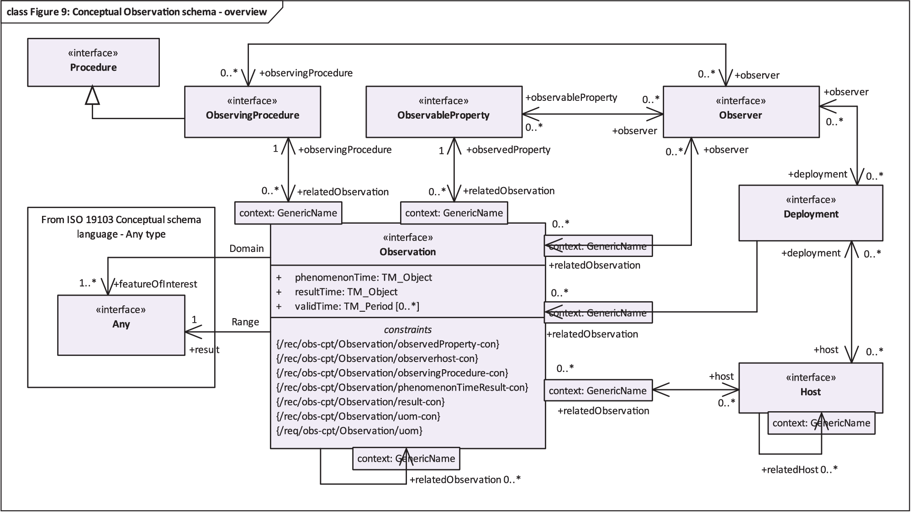
From Figure 9. Conceptual Observation schema overview (https://docs.ogc.org/as/20-082r4/20-082r4.html#_conceptual_observation_schema )

The Conceptual Observation Schema is composed of the following classes:
- Observation: an act carried out by an Observer to determine the value of an ObservableProperty of an object (featureOfInterest) by using an ObservingProcedure; the value is provided as the result.
- Procedure: a description of steps performed.
- ObservingProcedure: the description of steps performed in order to determine the value of an observableProperty by an Observer.
- ObservableProperty: a quality (property, characteristic) of the feature-of-interest that can be observed.
- Observer: an identifiable entity that can generate Observations pertaining to an observableProperty by implementing an ObservingProcedure.
- Deployment: information on the assignment of an Observer to a Host.
- Host: a grouping of Observers for a specific reason.

Conceptual Sample Model

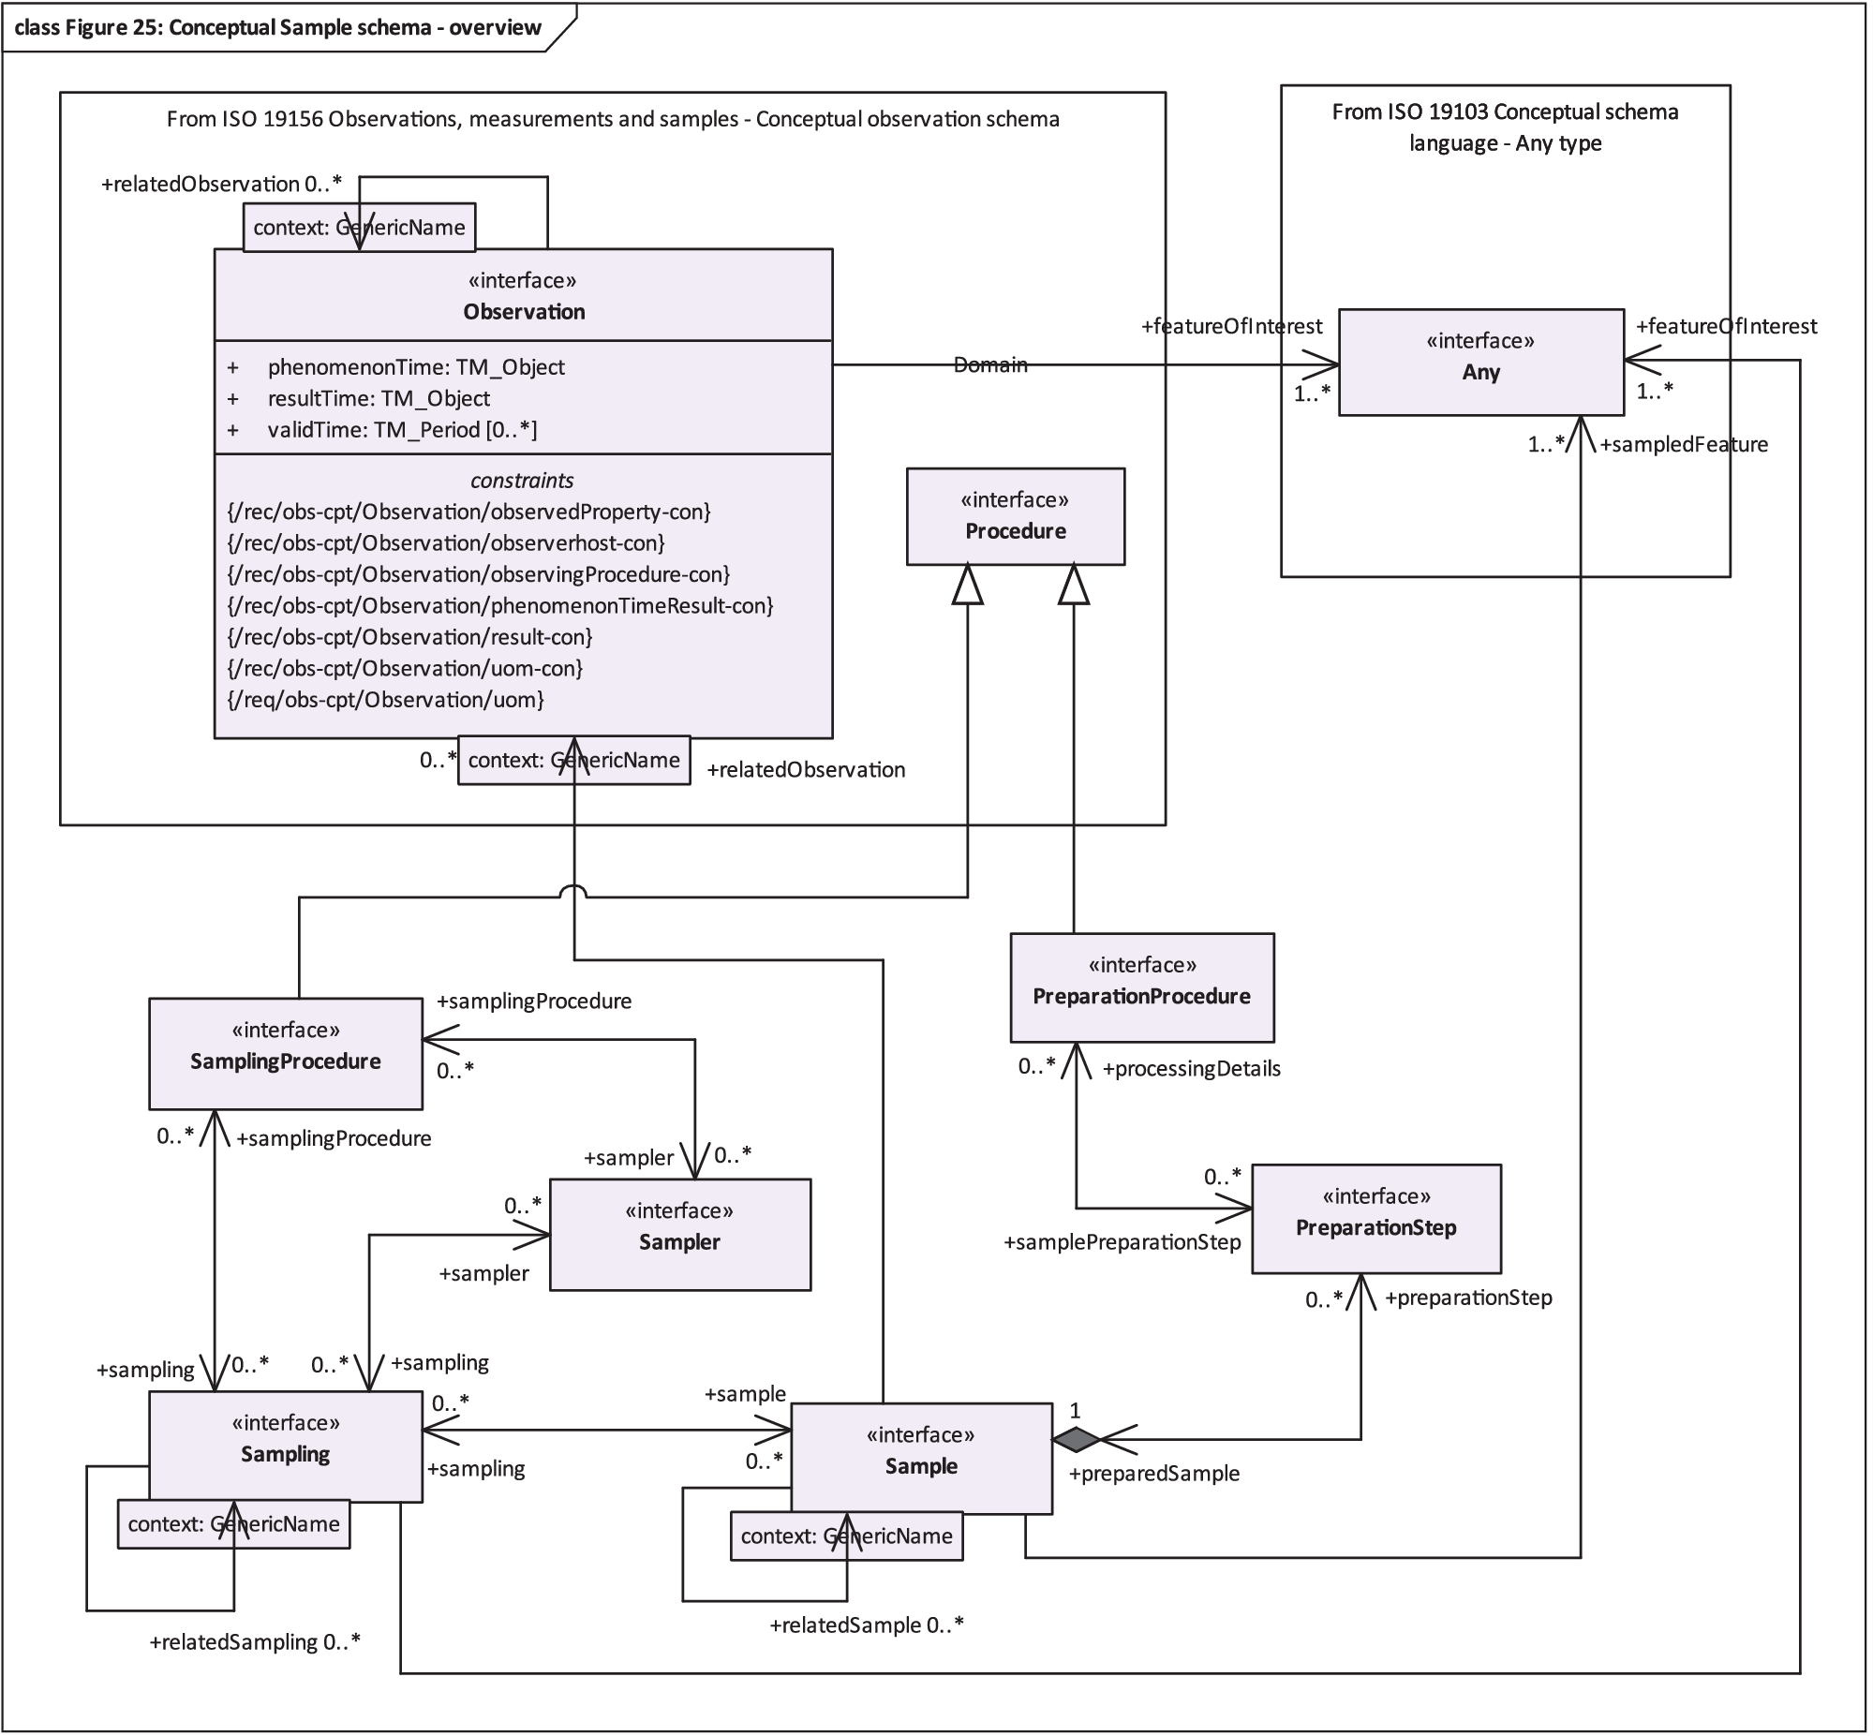
Figure 25. Conceptual Sample schema overview (https://docs.ogc.org/as/20-082r4/20-082r4.html#_conceptual_sample_schema )

Need Classes and their def from spec requirement
The Conceptual Sample Schema is composed of the following classes:
- Sample: an object that is representative of a concept, real-world object or phenomenon.
- Sampler: as a device or entity (including humans) that is used by, or implements, a SamplingProcedure to create or transform one or more Sample(s).
- Sampling: an act applying a SamplingProcedure to create or transform one or more Sample(s).
- SamplingProcedure: the description of steps performed by a Sampler in order to extract a Sample from its sampledFeature in the frame of a Sampling.
- PreparationStep: an individual step pertaining to a PreparationProcedure.
- PreparationProcedure: the description of preparation steps performed on a Sample.

SensorThings API 2.0 Draft WQ IE Mapping to OMS
The diagram below shows the mapping between OMS and the STA V2.0 draft. Most classes are aligned 1:1, with a few exceptions:
- STA:Sensor is aligned with OMS:Observer
- STA:Thing is aligned with OMS:Host
- STA:Datastream & STA:Observation together comprise an OMS:Observation

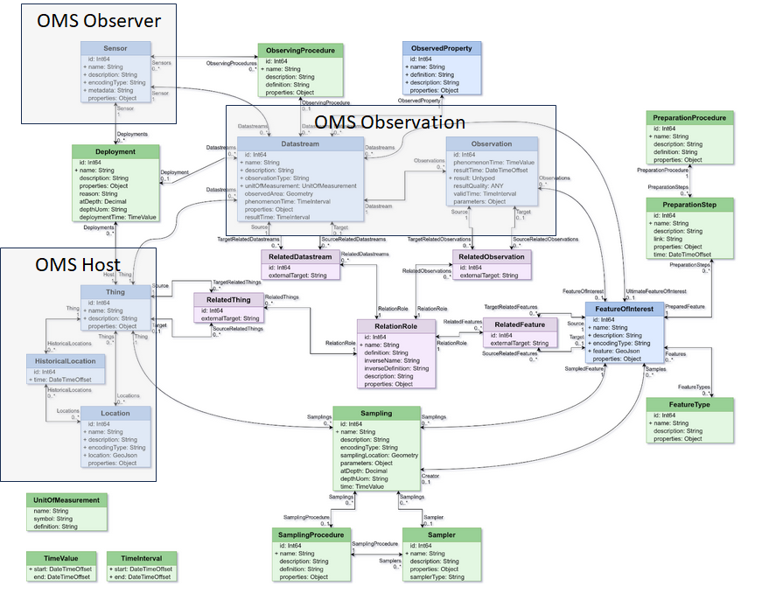

Annex V - Codelists

For now, in a first implementation round, we’ll use our national/organization codeLists (ideally available via Linked Data Best practices)
Which will help the next steps of the exercise : align-link our organization vocabularies.
Those mentioned below are suggestions for investigation (prototype).

Unit of Measure (UoM)
The use of https://qudt.org/ is strongly advised and documented by many communities.

ObservableProperties

ObservingProcedure
The BODC NERC Vocabulary Server (NVS) has a analytical method vocabulary containing both laboratory methods as well as sensors: NVS (nerc.ac.uk)

The US National Environmental Methods Index provides a comprehensive vocabulary of observing and sampling methods: National Environmental Methods Index (nemi.gov)

